UNITED STATES
SECURITIES AND EXCHANGE COMMISSION
WASHINGTON, D.C. 20549

FORM 8-K

CURRENT REPORT
Pursuant to Section 13 or 15(d) of the Securities Exchange Act of 1934
Date of Report (Date of earliest event reported): September 21, 2026

Metagenomi Therapeutics, Inc.
(Exact name of Registrant as Specified in Its Charter)

Delaware |  |  | 001-41949 | 81-3909017
(State or Other Jurisdiction  of Incorporation) |  |  | (Commission File Number) | (IRS Employer  Identification No.)
5959 Horton Street
7th Floor
Emeryville, California |  |  |  | 94608
(Address of Principal Executive Offices) |  |  |  | (Zip Code)

Registrant’s Telephone Number, Including Area Code: (510) 871-4880

(Former Name or Former Address, if Changed Since Last Report)

Check the appropriate box below if the Form 8-K filing is intended to simultaneously satisfy the filing obligation of the registrant under any of the following provisions:
☐Written communications pursuant to Rule 425 under the Securities Act (17 CFR 230.425)
☐Soliciting material pursuant to Rule 14a-12 under the Exchange Act (17 CFR 240.14a-12)
☐Pre-commencement communications pursuant to Rule 14d-2(b) under the Exchange Act (17 CFR 240.14d-2(b))
☐Pre-commencement communications pursuant to Rule 13e-4(c) under the Exchange Act (17 CFR 240.13e-4(c))
Securities registered pursuant to Section 12(b) of the Act:
Title of each class |  | Trading  Symbol(s) |  | Name of each exchange on which registered
Common Stock, $0.0001 par value per share |  | MGX |  | Nasdaq Global Select Market
Indicate by check mark whether the registrant is an emerging growth company as defined in Rule 405 of the Securities Act of 1933 (§ 230.405 of this chapter) or Rule 12b-2 of the Securities Exchange Act of 1934 (§ 240.12b-2 of this chapter).
Emerging growth company ☒
If an emerging growth company, indicate by check mark if the registrant has elected not to use the extended transition period for complying with any new or revised financial accounting standards provided pursuant to Section 13(a) of the Exchange Act. ☒

Item 7.01 Regulation FD Disclosure.
A copy of the Metagenomi Therapeutics, Inc. September 2026 corporate presentation is furnished as Exhibit 99.1 to this Current Report on Form 8-K and is incorporated herein by reference.
The information contained in this Item 7.01 (including Exhibit 99.1) is being furnished and shall not be deemed “filed” for purposes of Section 18 of the Securities Exchange Act of 1934, as amended (the “Exchange Act”), or otherwise subject to the liabilities of that section and shall not be deemed incorporated by reference in any filing under the Securities Act of 1933, as amended, or the Exchange Act, except as shall be expressly set forth by specific reference in such filing.
Item 9.01 Financial Statements and Exhibits.
(d) Exhibits
Exhibit No. |  | Description
99.1 |  | Corporate Presentation of Metagenomi Therapeutics, Inc. dated September 2026
104 |  | Cover Page Interactive Data File (embedded within the Inline XBRL document)

SIGNATURES
Pursuant to the requirements of the Securities Exchange Act of 1934, the registrant has duly caused this report to be signed on its behalf by the undersigned hereunto duly authorized.
 |  |  | Metagenomi Therapeutics, Inc.
Date: | September 21, 2026 | By: | /s/ Jian Irish
Jian Irish, Ph.D., M.B.A.
President and Chief Executive Officer


Precision gene editing designed to deliver durable, curative medicines Corporate Presentation September 2026

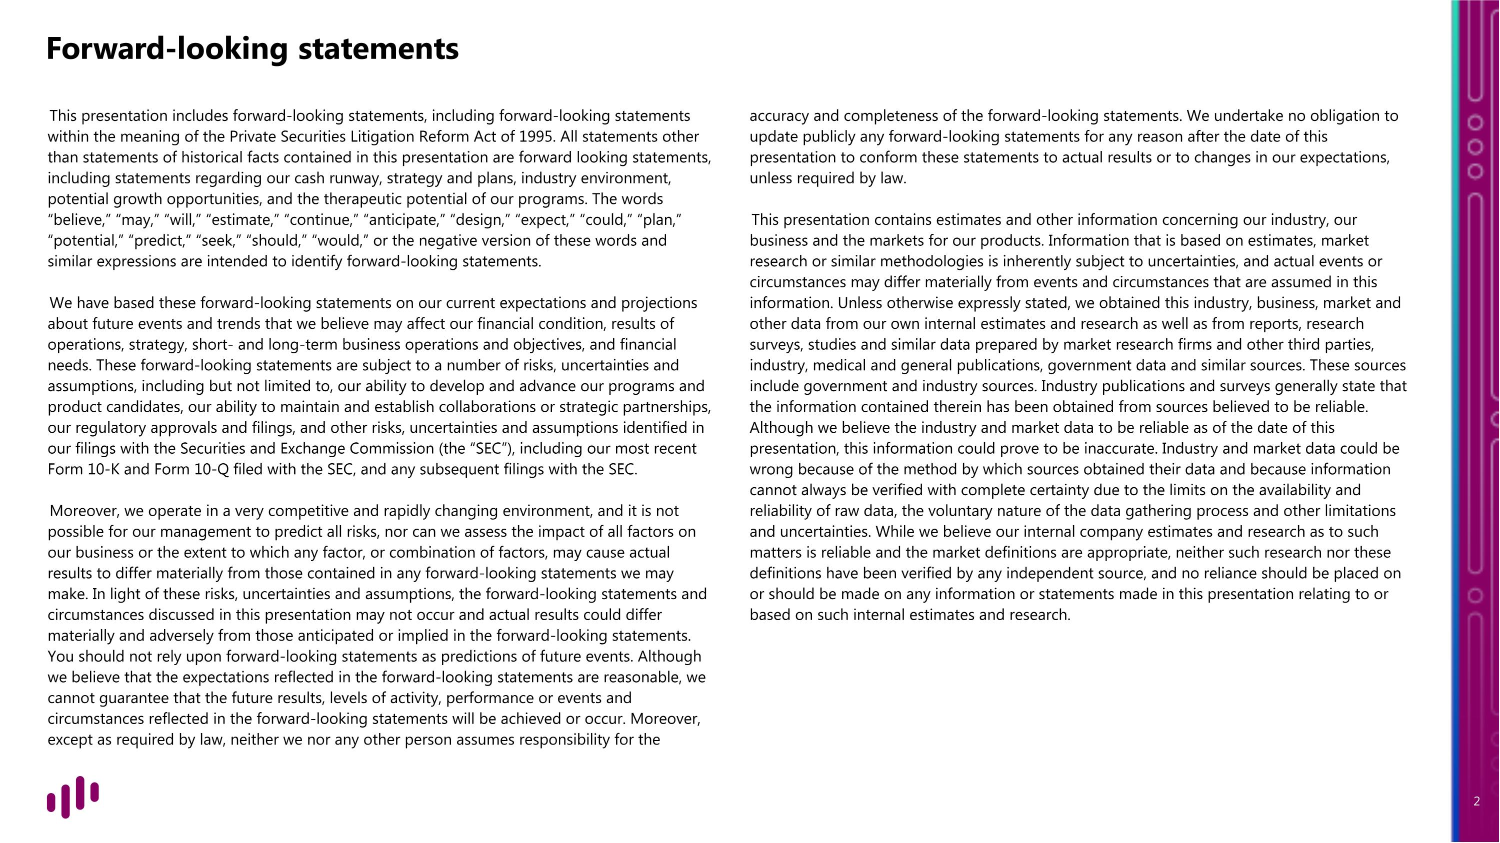
This presentation includes forward-looking statements, including forward-looking statements within the meaning of the Private Securities Litigation Reform Act of 1995. All statements other than statements of historical facts contained in this presentation are forward looking statements, including statements regarding our cash runway, strategy and plans, industry environment, potential growth opportunities, and the therapeutic potential of our programs. The words “believe,” “may,” “will,” “estimate,” “continue,” “anticipate,” “design,” “expect,” “could,” “plan,” “potential,” “predict,” “seek,” “should,” “would,” or the negative version of these words and similar expressions are intended to identify forward-looking statements. We have based these forward-looking statements on our current expectations and projections about future events and trends that we believe may affect our financial condition, results of operations, strategy, short- and long-term business operations and objectives, and financial needs. These forward-looking statements are subject to a number of risks, uncertainties and assumptions, including but not limited to, our ability to develop and advance our programs and product candidates, our ability to maintain and establish collaborations or strategic partnerships, our regulatory approvals and filings, and other risks, uncertainties and assumptions identified in our filings with the Securities and Exchange Commission (the “SEC”), including our most recent Form 10-K and Form 10-Q filed with the SEC, and any subsequent filings with the SEC. Moreover, we operate in a very competitive and rapidly changing environment, and it is not possible for our management to predict all risks, nor can we assess the impact of all factors on our business or the extent to which any factor, or combination of factors, may cause actual results to differ materially from those contained in any forward-looking statements we may make. In light of these risks, uncertainties and assumptions, the forward-looking statements and circumstances discussed in this presentation may not occur and actual results could differ materially and adversely from those anticipated or implied in the forward-looking statements. You should not rely upon forward-looking statements as predictions of future events. Although we believe that the expectations reflected in the forward-looking statements are reasonable, we cannot guarantee that the future results, levels of activity, performance or events and circumstances reflected in the forward-looking statements will be achieved or occur. Moreover, except as required by law, neither we nor any other person assumes responsibility for the accuracy and completeness of the forward-looking statements. We undertake no obligation to update publicly any forward-looking statements for any reason after the date of this presentation to conform these statements to actual results or to changes in our expectations, unless required by law. This presentation contains estimates and other information concerning our industry, our business and the markets for our products. Information that is based on estimates, market research or similar methodologies is inherently subject to uncertainties, and actual events or circumstances may differ materially from events and circumstances that are assumed in this information. Unless otherwise expressly stated, we obtained this industry, business, market and other data from our own internal estimates and research as well as from reports, research surveys, studies and similar data prepared by market research firms and other third parties, industry, medical and general publications, government data and similar sources. These sources include government and industry sources. Industry publications and surveys generally state that the information contained therein has been obtained from sources believed to be reliable. Although we believe the industry and market data to be reliable as of the date of this presentation, this information could prove to be inaccurate. Industry and market data could be wrong because of the method by which sources obtained their data and because information cannot always be verified with complete certainty due to the limits on the availability and reliability of raw data, the voluntary nature of the data gathering process and other limitations and uncertainties. While we believe our internal company estimates and research as to such matters is reliable and the market definitions are appropriate, neither such research nor these definitions have been verified by any independent source, and no reliance should be placed on or should be made on any information or statements made in this presentation relating to or based on such internal estimates and research. Forward-looking statements

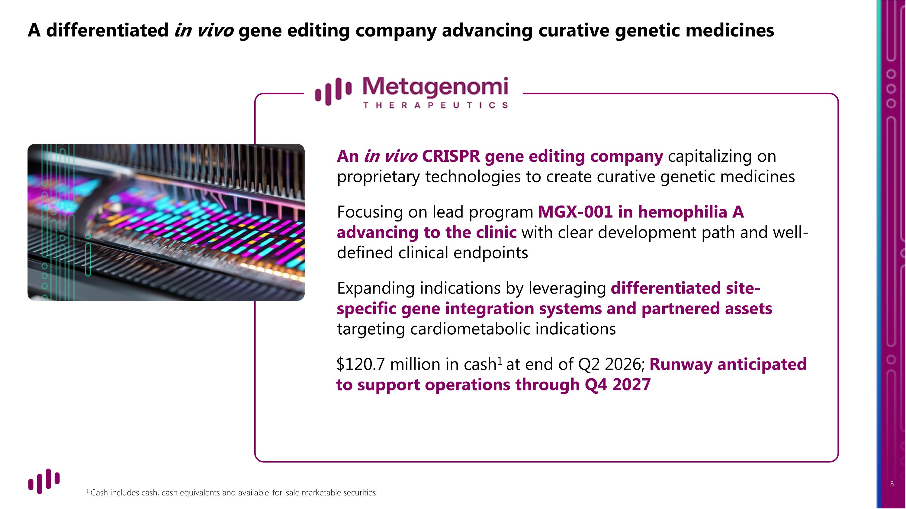
A differentiated in vivo gene editing company advancing curative genetic medicines 1 Cash includes cash, cash equivalents and available-for-sale marketable securities An in vivo CRISPR gene editing company capitalizing on proprietary technologies to create curative genetic medicines Focusing on lead program MGX-001 in hemophilia A advancing to the clinic with clear development path and well-defined clinical endpoints Expanding indications by leveraging differentiated site-specific gene integration systems and partnered assets targeting cardiometabolic indications $120.7 million in cash1 at end of Q2 2026; Runway anticipated to support operations through Q4 2027

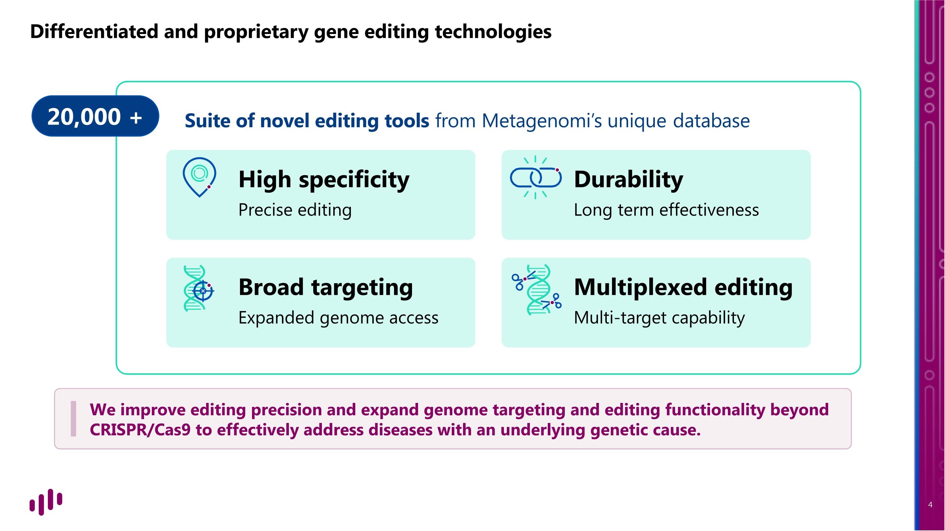
20,000 + Differentiated and proprietary gene editing technologies Suite of novel editing tools from Metagenomi’s unique database High specificity Precise editing Multiplexed editing Multi-target capability Durability Long term effectiveness Broad targeting Expanded genome access We improve editing precision and expand genome targeting and editing functionality beyond CRISPR/Cas9 to effectively address diseases with an underlying genetic cause.

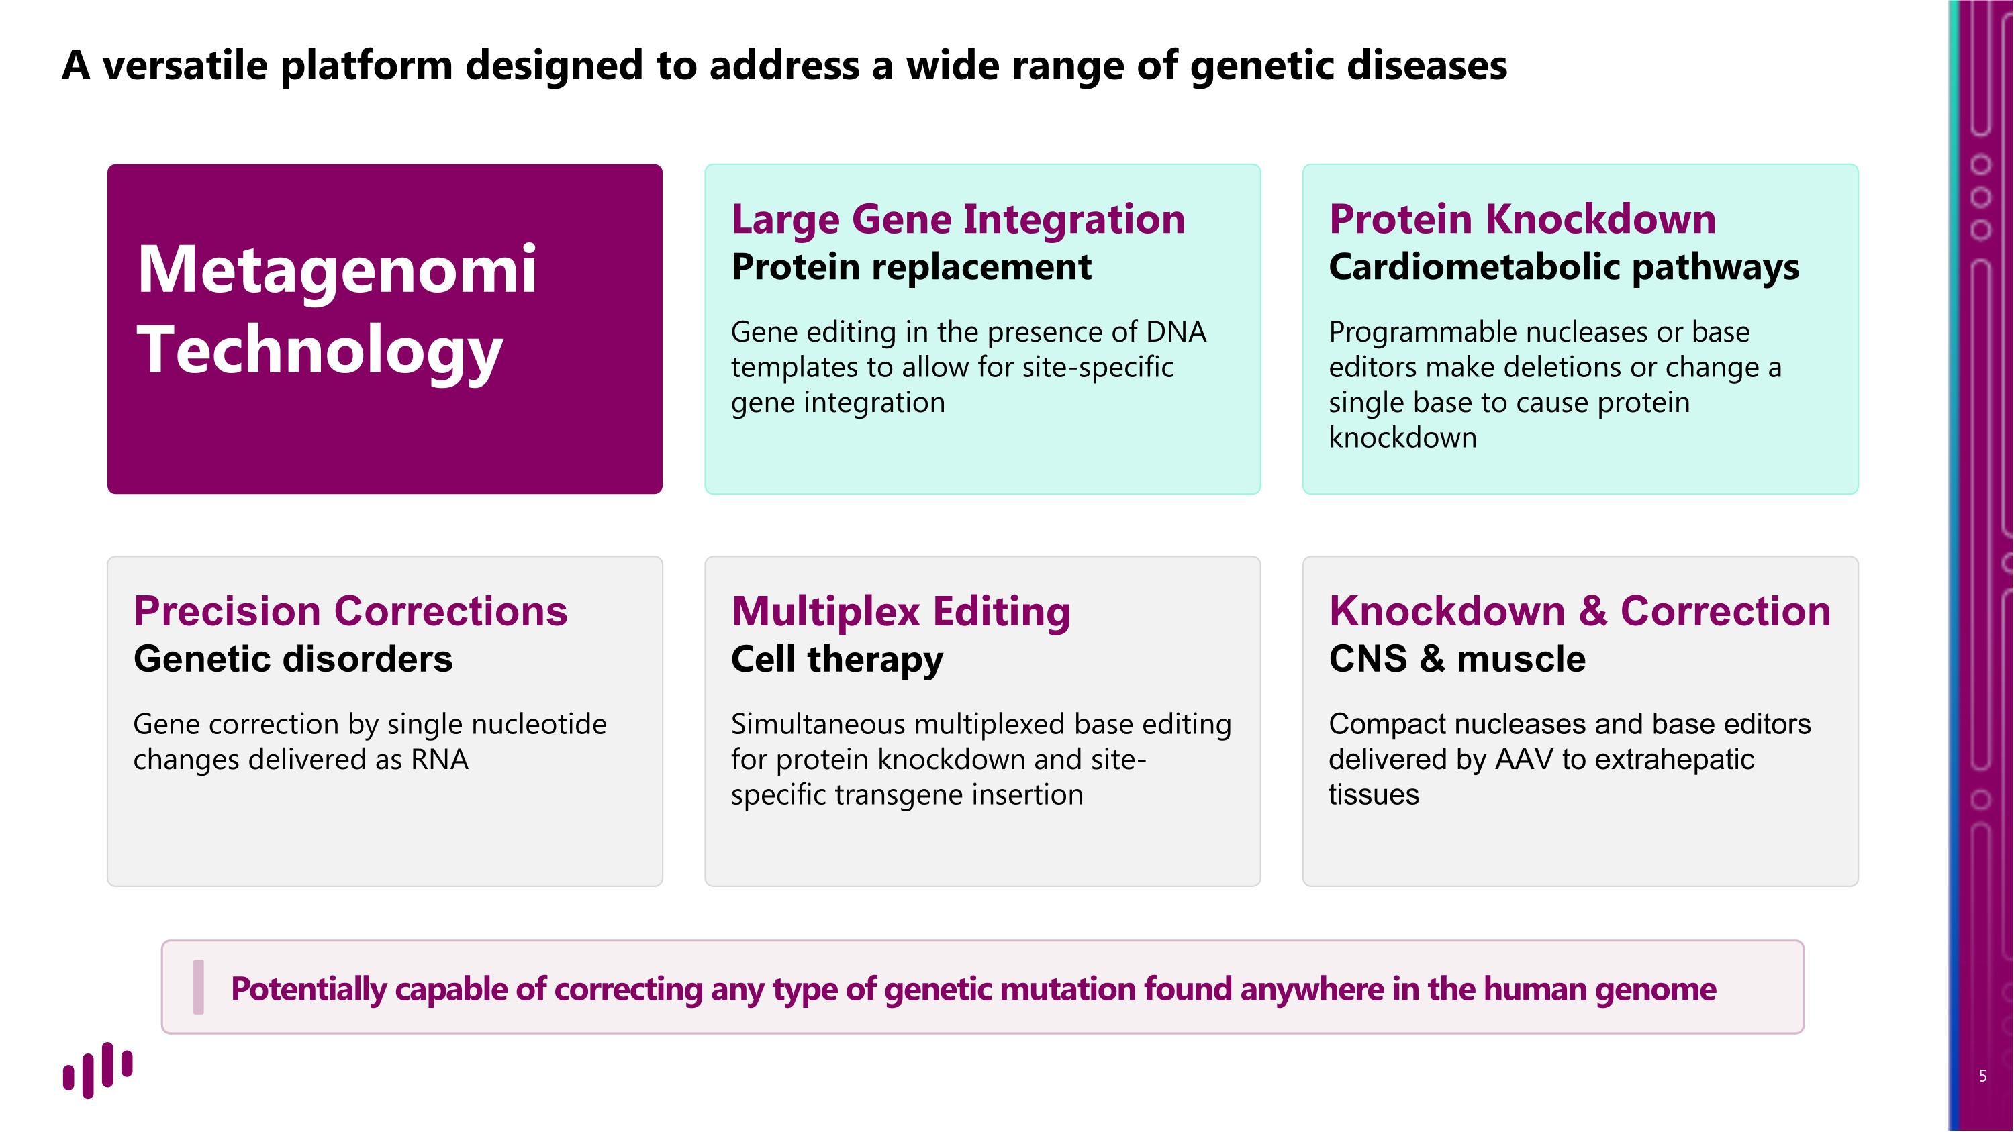
A versatile platform designed to address a wide range of genetic diseases Potentially capable of correcting any type of genetic mutation found anywhere in the human genome Metagenomi
Technology Large Gene Integration Protein replacement Gene editing in the presence of DNA templates to allow for site-specific gene integration Protein Knockdown Cardiometabolic pathways Programmable nucleases or base editors make deletions or change a single base to cause protein knockdown Precision Corrections Genetic disorders Gene correction by single nucleotide changes delivered as RNA Multiplex Editing ?Cell therapy Simultaneous multiplexed base editing for protein knockdown and site-specific transgene insertion Knockdown & Correction ?CNS & muscle Compact nucleases and base editors delivered by AAV to extrahepatic tissues

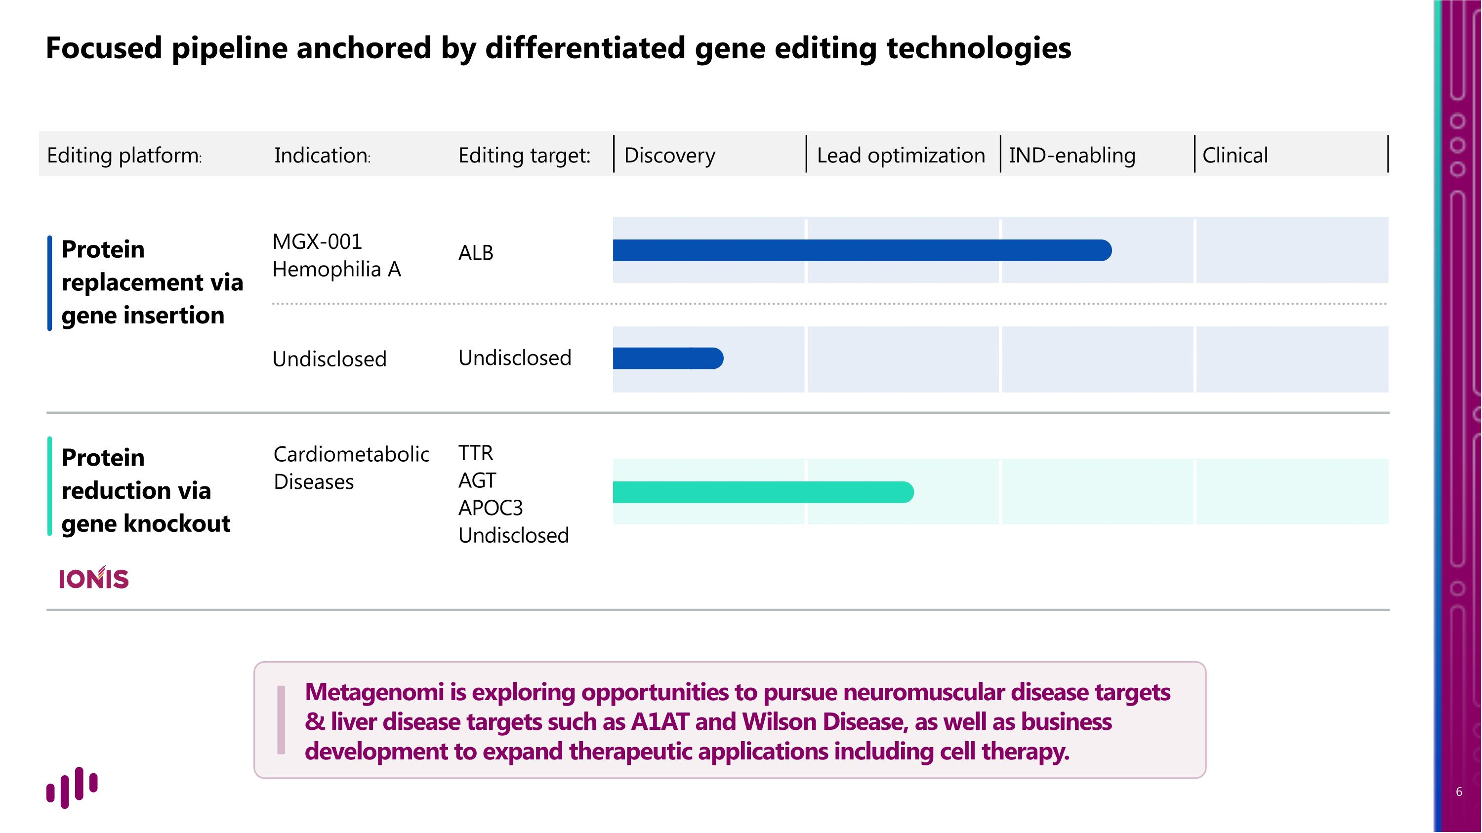
Protein replacement via gene insertion Protein reduction via gene knockout ALB MGX-001 Hemophilia A Undisclosed Undisclosed TTR AGT APOC3 Undisclosed Cardiometabolic Diseases Editing platform: Editing target: Discovery Lead optimization IND-enabling Clinical Indication: Focused pipeline anchored by differentiated gene editing technologies Metagenomi is exploring opportunities to pursue neuromuscular disease targets & liver disease targets such as A1AT and Wilson Disease, as well as business development to expand therapeutic applications including cell therapy.

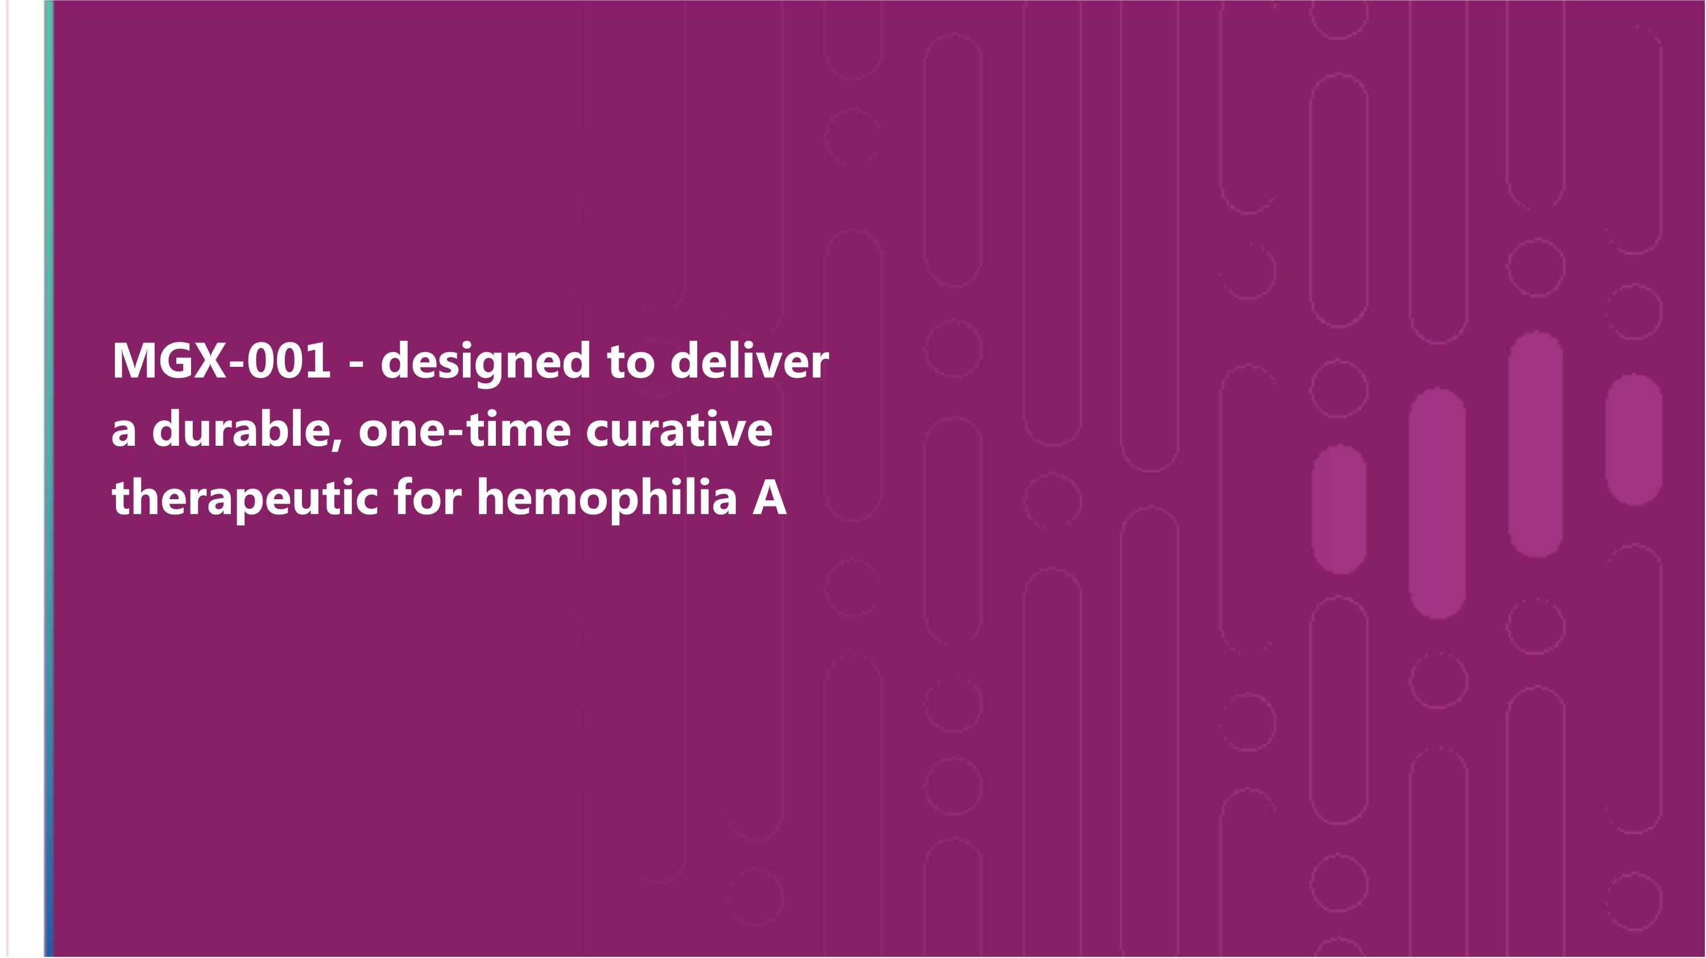
MGX-001 - designed to deliver a durable, one-time curative therapeutic for hemophilia A

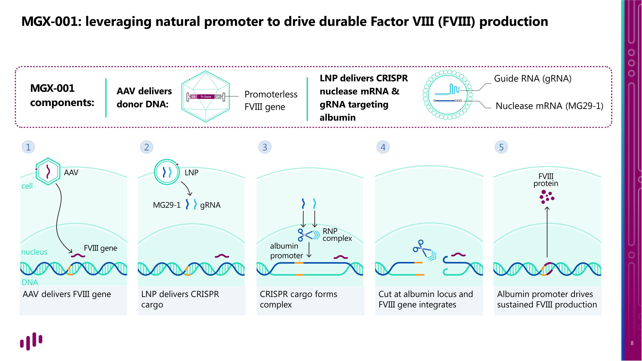
AAV delivers FVIII gene LNP delivers CRISPR cargo CRISPR cargo forms complex Cut at albumin locus and FVIII gene integrates Albumin promoter drives sustained FVIII production MGX-001: leveraging natural promoter to drive durable Factor VIII (FVIII) production AAV delivers donor DNA: Promoterless FVIII gene MGX-001 components: Guide RNA (gRNA) Nuclease mRNA (MG29-1) LNP delivers CRISPR nuclease mRNA & gRNA targeting albumin AAV cell nucleus DNA LNP gRNA MG29-1 FVIII protein albumin promoter RNP complex FVIII gene 1 2 3 4 5

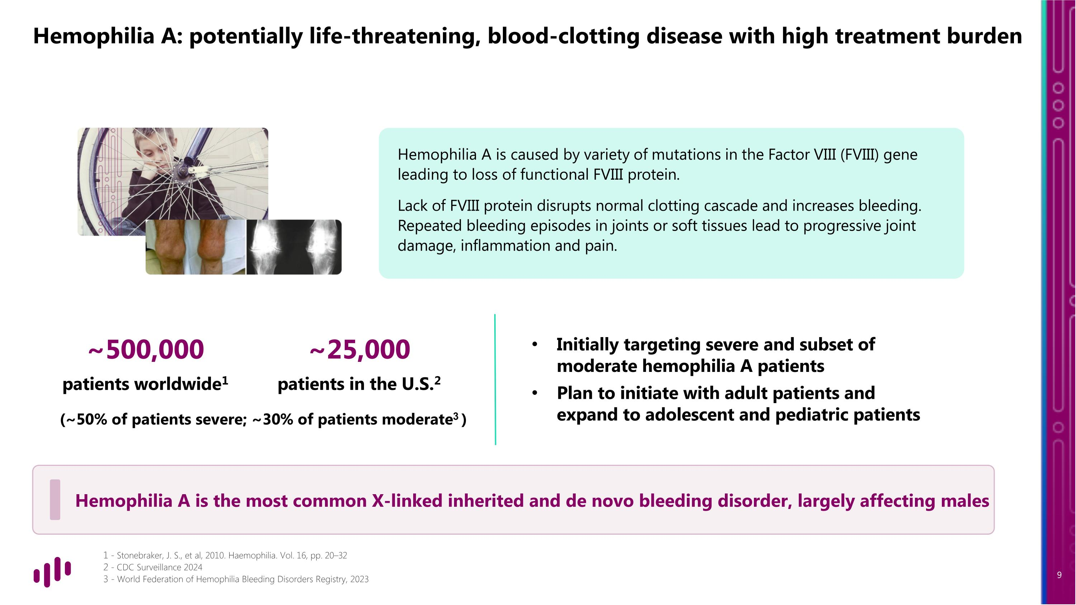
~25,000 patients in the U.S.2 Hemophilia A: potentially life-threatening, blood-clotting disease with high treatment burden - Stonebraker, J. S., et al, 2010. Haemophilia. Vol. 16, pp. 20–32 - CDC Surveillance 2024 - World Federation of Hemophilia Bleeding Disorders Registry, 2023 Hemophilia A is caused by variety of mutations in the Factor VIII (FVIII) gene leading to loss of functional FVIII protein. Lack of FVIII protein disrupts normal clotting cascade and increases bleeding. Repeated bleeding episodes in joints or soft tissues lead to progressive joint damage, inflammation and pain. 1 Initially targeting severe and subset of moderate hemophilia A patients Plan to initiate with adult patients and expand to adolescent and pediatric patients ~500,000 patients worldwide1 Hemophilia A is the most common X-linked inherited and de novo bleeding disorder, largely affecting males (~50% of patients severe; ~30% of patients moderate3 )

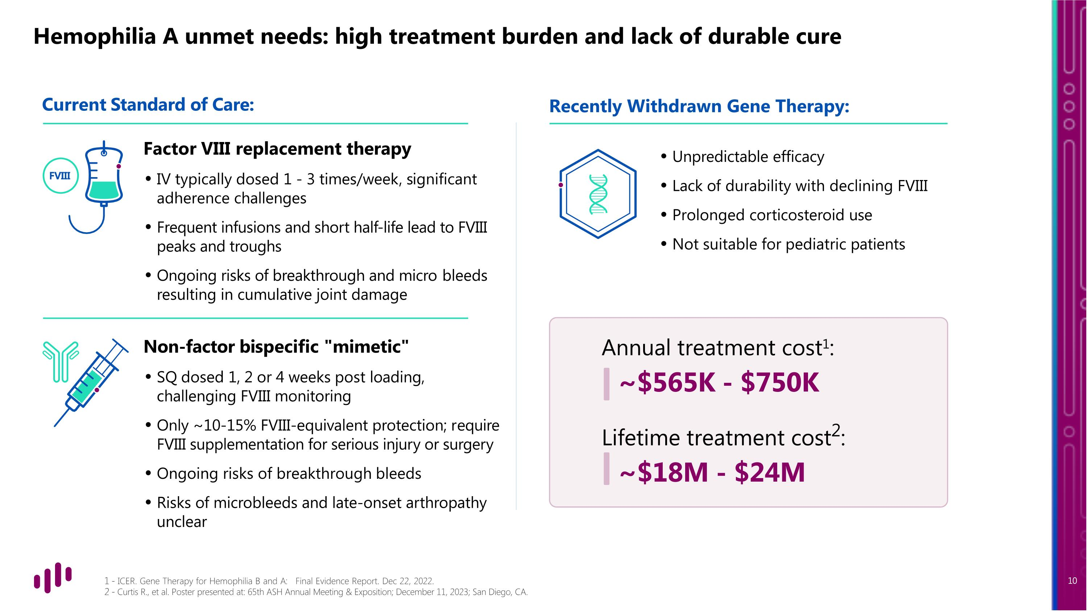
Hemophilia A unmet needs: high treatment burden and lack of durable cure - ICER. Gene Therapy for Hemophilia B and A: Final Evidence Report. Dec 22, 2022. - Curtis R., et al. Poster presented at: 65th ASH Annual Meeting & Exposition; December 11, 2023; San Diego, CA. Current Standard of Care: Factor VIII replacement therapy IV typically dosed 1 - 3 times/week, significant adherence challenges Frequent infusions and short half-life lead to FVIII peaks and troughs Ongoing risks of breakthrough and micro bleeds resulting in cumulative joint damage Non-factor bispecific "mimetic" SQ dosed 1, 2 or 4 weeks post loading, challenging FVIII monitoring Only ~10-15% FVIII-equivalent protection; require FVIII supplementation for serious injury or surgery Ongoing risks of breakthrough bleeds Risks of microbleeds and late-onset arthropathy unclear Unpredictable efficacy Lack of durability with declining FVIII Prolonged corticosteroid use Not suitable for pediatric patients Annual treatment cost1: ~$565K - $750K Lifetime treatment cost2: ~$18M - $24M FVIII Recently Withdrawn Gene Therapy:

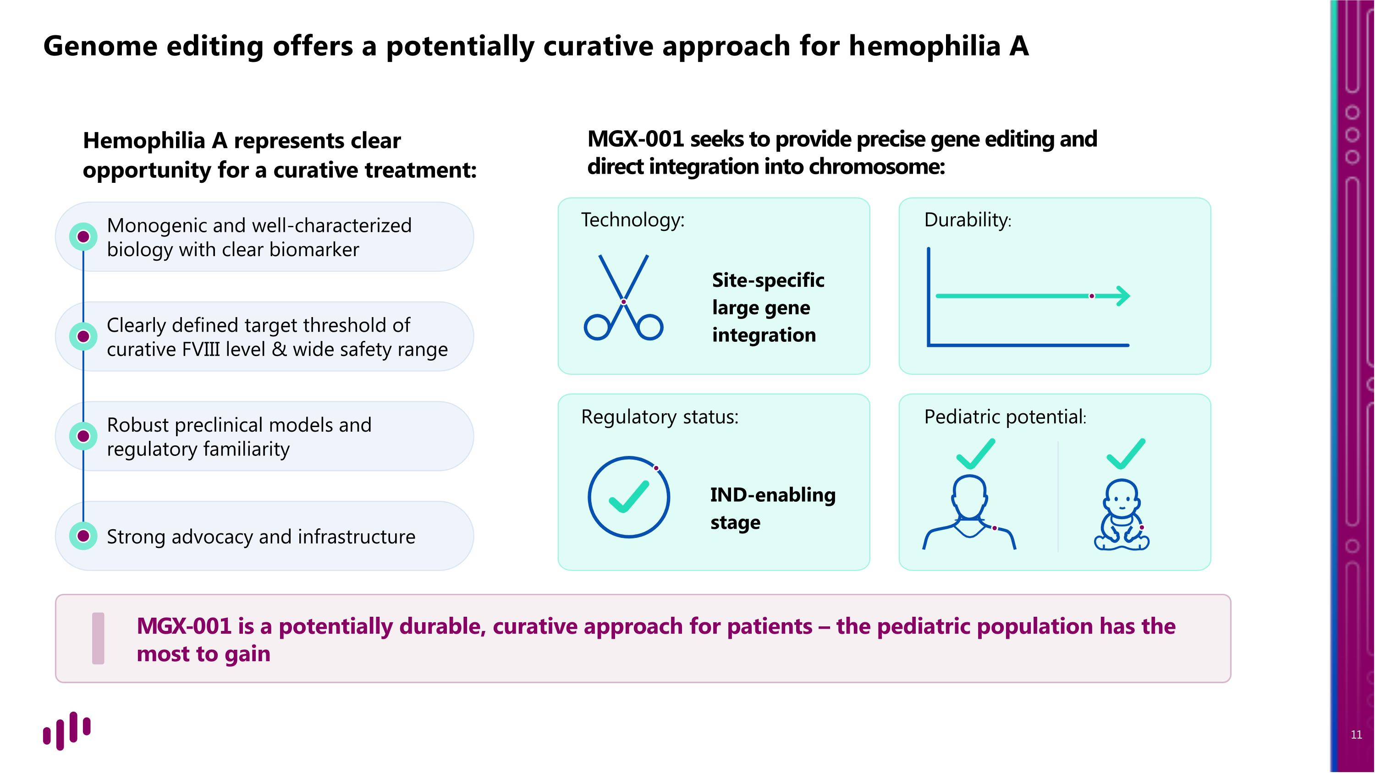
Strong advocacy and infrastructure Robust preclinical models and regulatory familiarity Clearly defined target threshold of curative FVIII level & wide safety range Monogenic and well-characterized biology with clear biomarker Genome editing offers a potentially curative approach for hemophilia A Site-specific large gene integration IND-enabling stage Technology: Durability: Regulatory status: Pediatric potential: Hemophilia A represents clear opportunity for a curative treatment: MGX-001 seeks to provide precise gene editing and direct integration into chromosome: MGX-001 is a potentially durable, curative approach for patients – the pediatric population has the most to gain

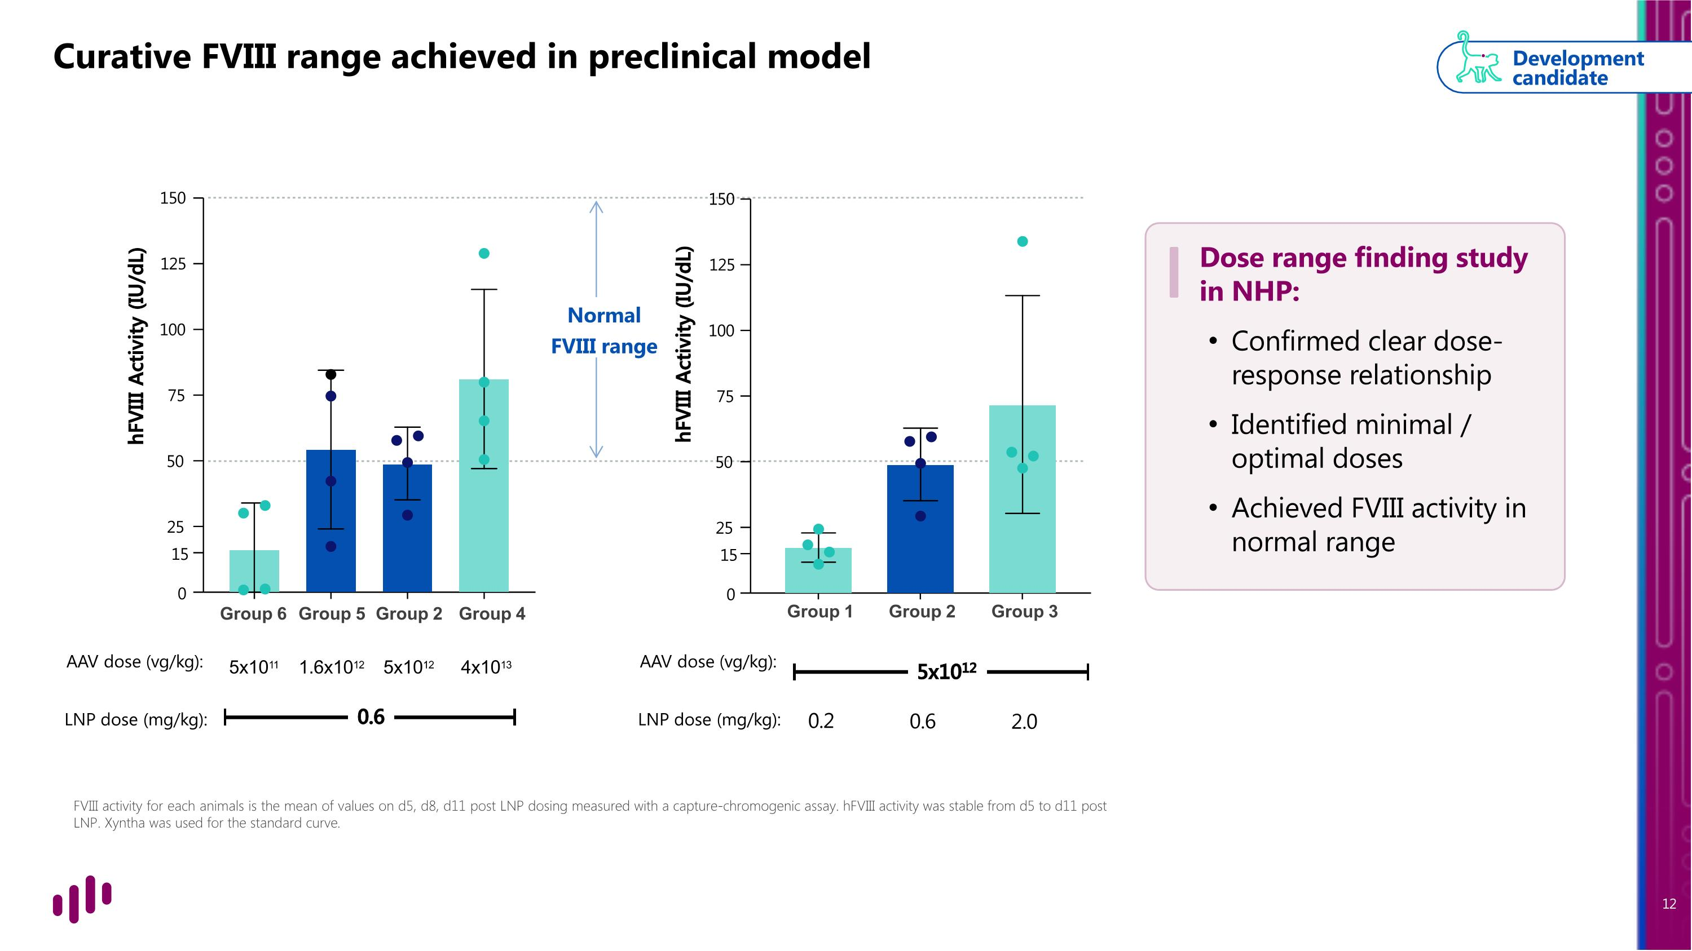
Curative FVIII range achieved in preclinical model FVIII activity for each animals is the mean of values on d5, d8, d11 post LNP dosing measured with a capture-chromogenic assay. hFVIII activity was stable from d5 to d11 post LNP. Xyntha was used for the standard curve. Normal FVIII range Development candidate 25 15 0 50 75 100 125 150 hFVIII Activity (IU/dL) Group 6 Group 5 Group 2 Group 4 AAV dose (vg/kg): 5x1011 1.6x1012 5x1012 4x1013 LNP dose (mg/kg): 0.6 hFVIII Activity (IU/dL) 25 15 0 50 75 100 125 150 Group 2 Group 3 5x1012 0.6 2.0 Group 1 0.2 AAV dose (vg/kg): LNP dose (mg/kg): Dose range finding study in NHP: Confirmed clear dose-response relationship Identified minimal / optimal doses Achieved FVIII activity in normal range

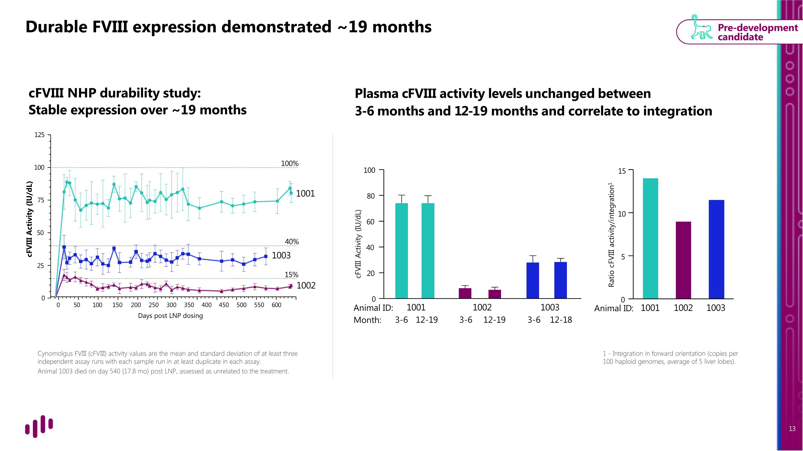
Durable FVIII expression demonstrated ~19 months cFVIII NHP durability study: Stable expression over ~19 months Plasma cFVIII activity levels unchanged between ?3-6 months and 12-19 months and correlate to integration Cynomolgus FVIII (cFVIII) activity values are the mean and standard deviation of at least three independent assay runs with each sample run in at least duplicate in each assay. Animal 1003 died on day 540 (17.8 mo) post LNP, assessed as unrelated to the treatment. 1 - Integration in forward orientation (copies per 100 haploid genomes, average of 5 liver lobes). Pre-development candidate 0 20 40 60 80 100 cFVIII Activity (IU/dL) 1001 3-6 12-19 1002 3-6 12-19 1003 3-6 12-18 Animal ID: Ratio cFVIII activity/integration1 0 5 10 15 1001 1002 1003 0 50 100 150 200 250 300 350 400 450 500 550 600 100 75 50 25 0 125 1001 1003 40% 15% 1002 cFVIII Activity (IU/dL) Days post LNP dosing 100% Animal ID: Month:

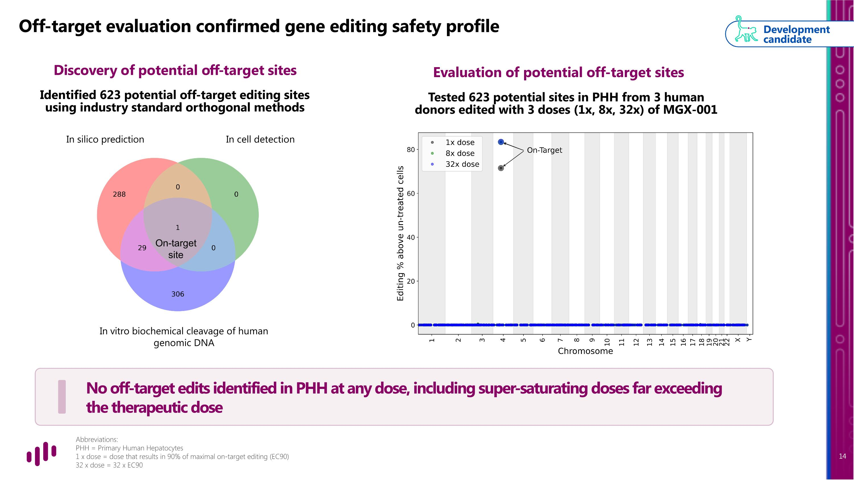
Off-target evaluation confirmed gene editing safety profile Discovery of potential off-target sites Identified 623 potential off-target editing sites using industry standard orthogonal methods Development candidate On-target site Evaluation of potential off-target sites In silico prediction In cell detection In vitro biochemical cleavage of human genomic DNA Abbreviations: PHH = Primary Human Hepatocytes 1 x dose = dose that results in 90% of maximal on-target editing (EC90) 32 x dose = 32 x EC90 Tested 623 potential sites in PHH from 3 human donors edited with 3 doses (1x, 8x, 32x) of MGX-001 No off-target edits identified in PHH at any dose, including super-saturating doses far exceeding the therapeutic dose

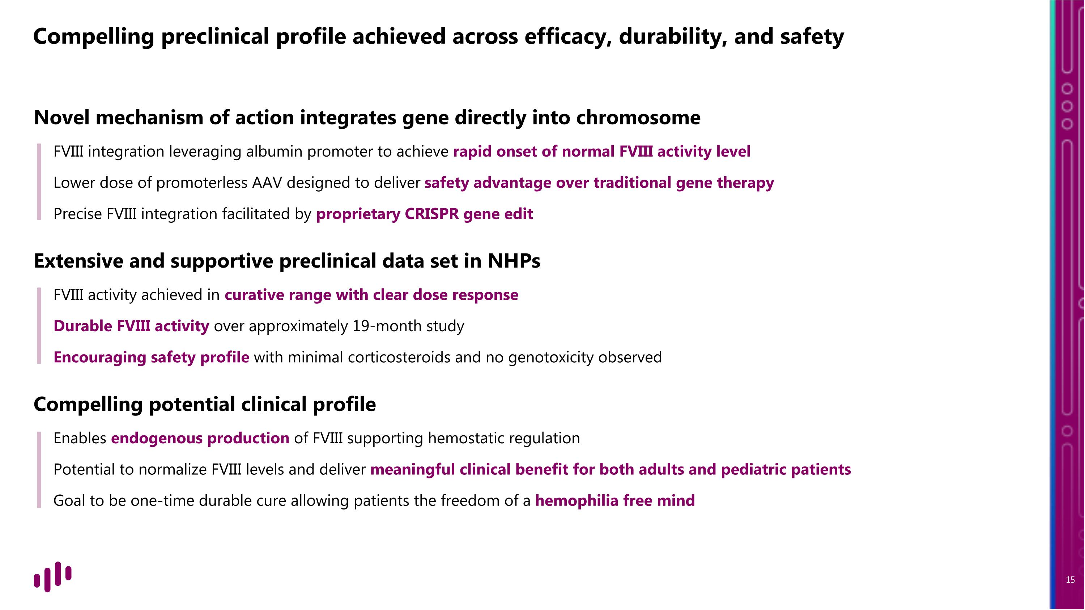
Novel mechanism of action integrates gene directly into chromosome FVIII integration leveraging albumin promoter to achieve rapid onset of normal FVIII activity level Lower dose of promoterless AAV designed to deliver safety advantage over traditional gene therapy Precise FVIII integration facilitated by proprietary CRISPR gene edit Extensive and supportive preclinical data set in NHPs FVIII activity achieved in curative range with clear dose response Durable FVIII activity over approximately 19-month study Encouraging safety profile with minimal corticosteroids and no genotoxicity observed Compelling potential clinical profile Enables endogenous production of FVIII supporting hemostatic regulation Potential to normalize FVIII levels and deliver meaningful clinical benefit for both adults and pediatric patients Goal to be one-time durable cure allowing patients the freedom of a hemophilia free mind Compelling preclinical profile achieved across efficacy, durability, and safety

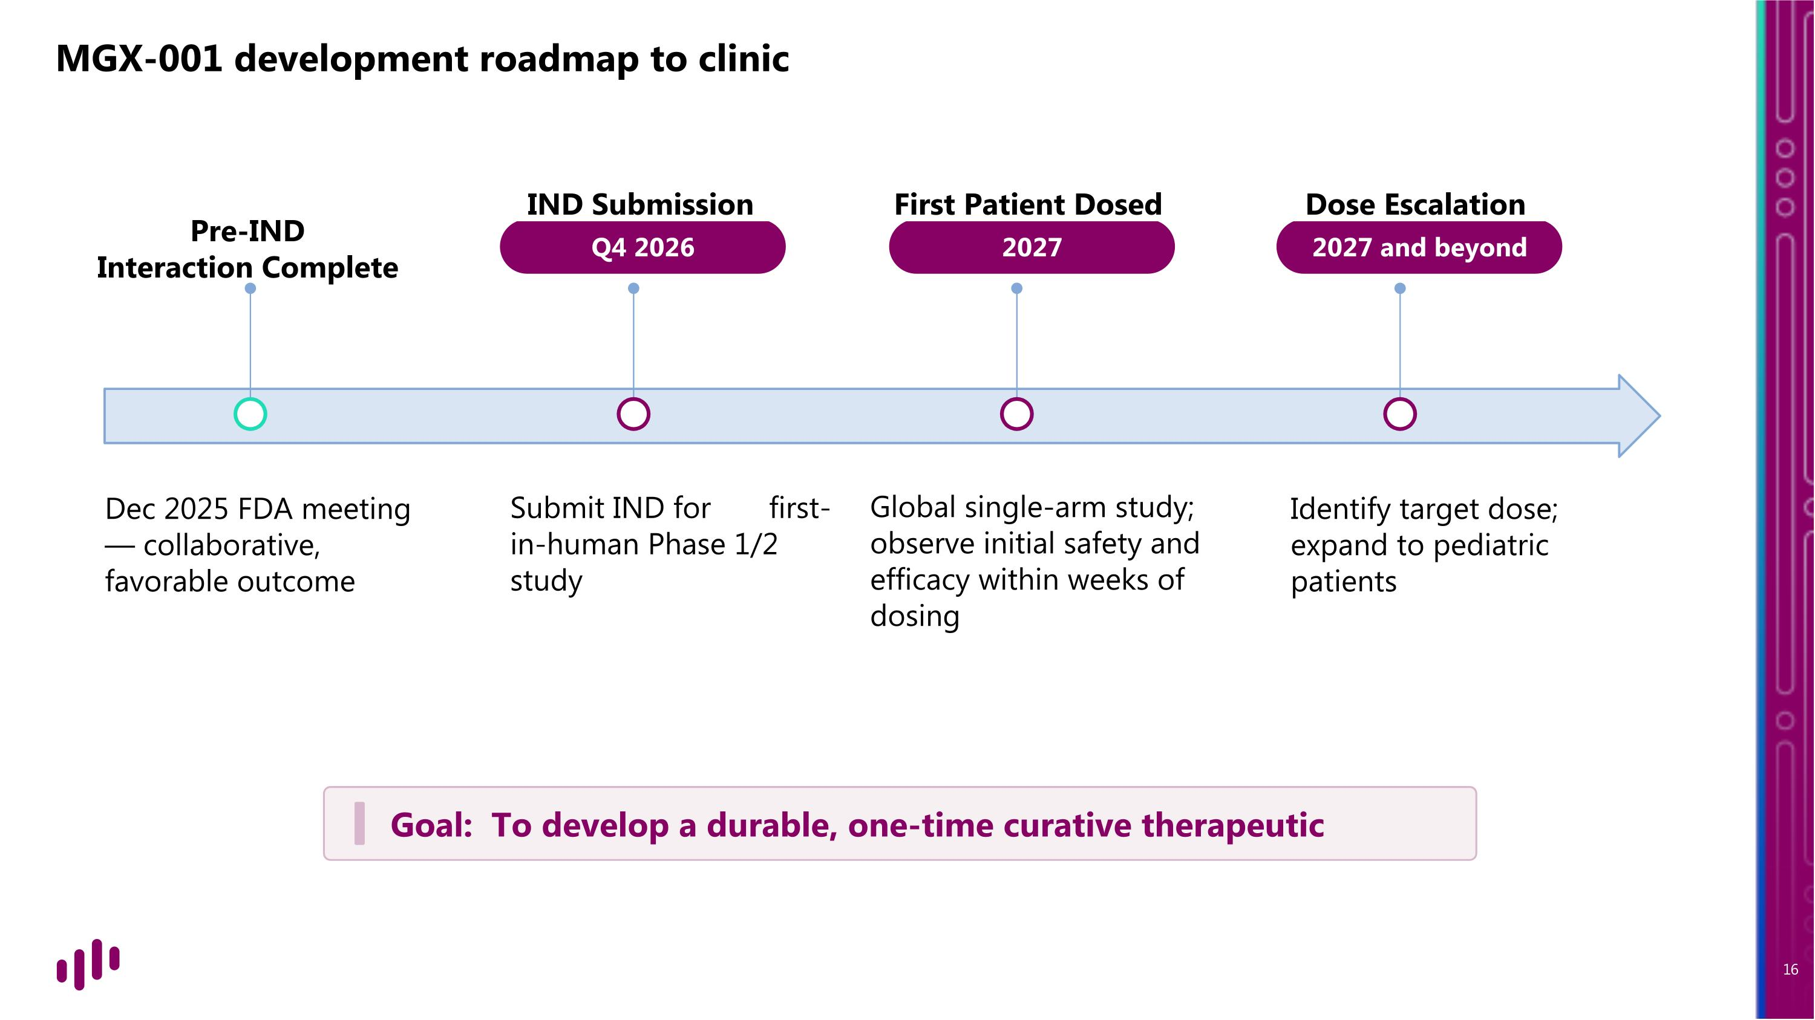
Pre-IND ?Interaction Complete Dec 2025 FDA meeting — collaborative, favorable outcome Q4 2026 IND Submission Submit IND for first-in-human Phase 1/2 study 2027 First Patient Dosed Global single-arm study; observe initial safety and efficacy within weeks of dosing 2027 and beyond Dose Escalation Identify target dose; expand to pediatric patients MGX-001 development roadmap to clinic Goal: To develop a durable, one-time curative therapeutic


Broaden therapeutic potential with transformative gene editing?

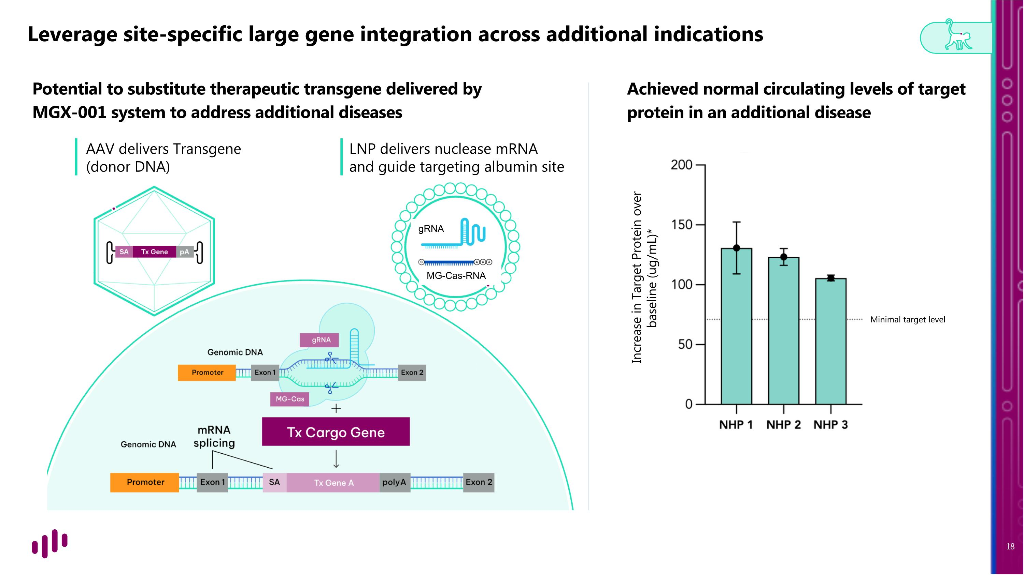
Leverage site-specific large gene integration across additional indications Potential to substitute therapeutic transgene delivered by MGX-001 system to address additional diseases Achieved normal circulating levels of target protein in an additional disease Minimal target level Increase in Target Protein over baseline (ug/mL)* LNP delivers nuclease mRNA ?and guide targeting albumin site AAV delivers Transgene?(donor DNA) gRNA MG-Cas-RNA

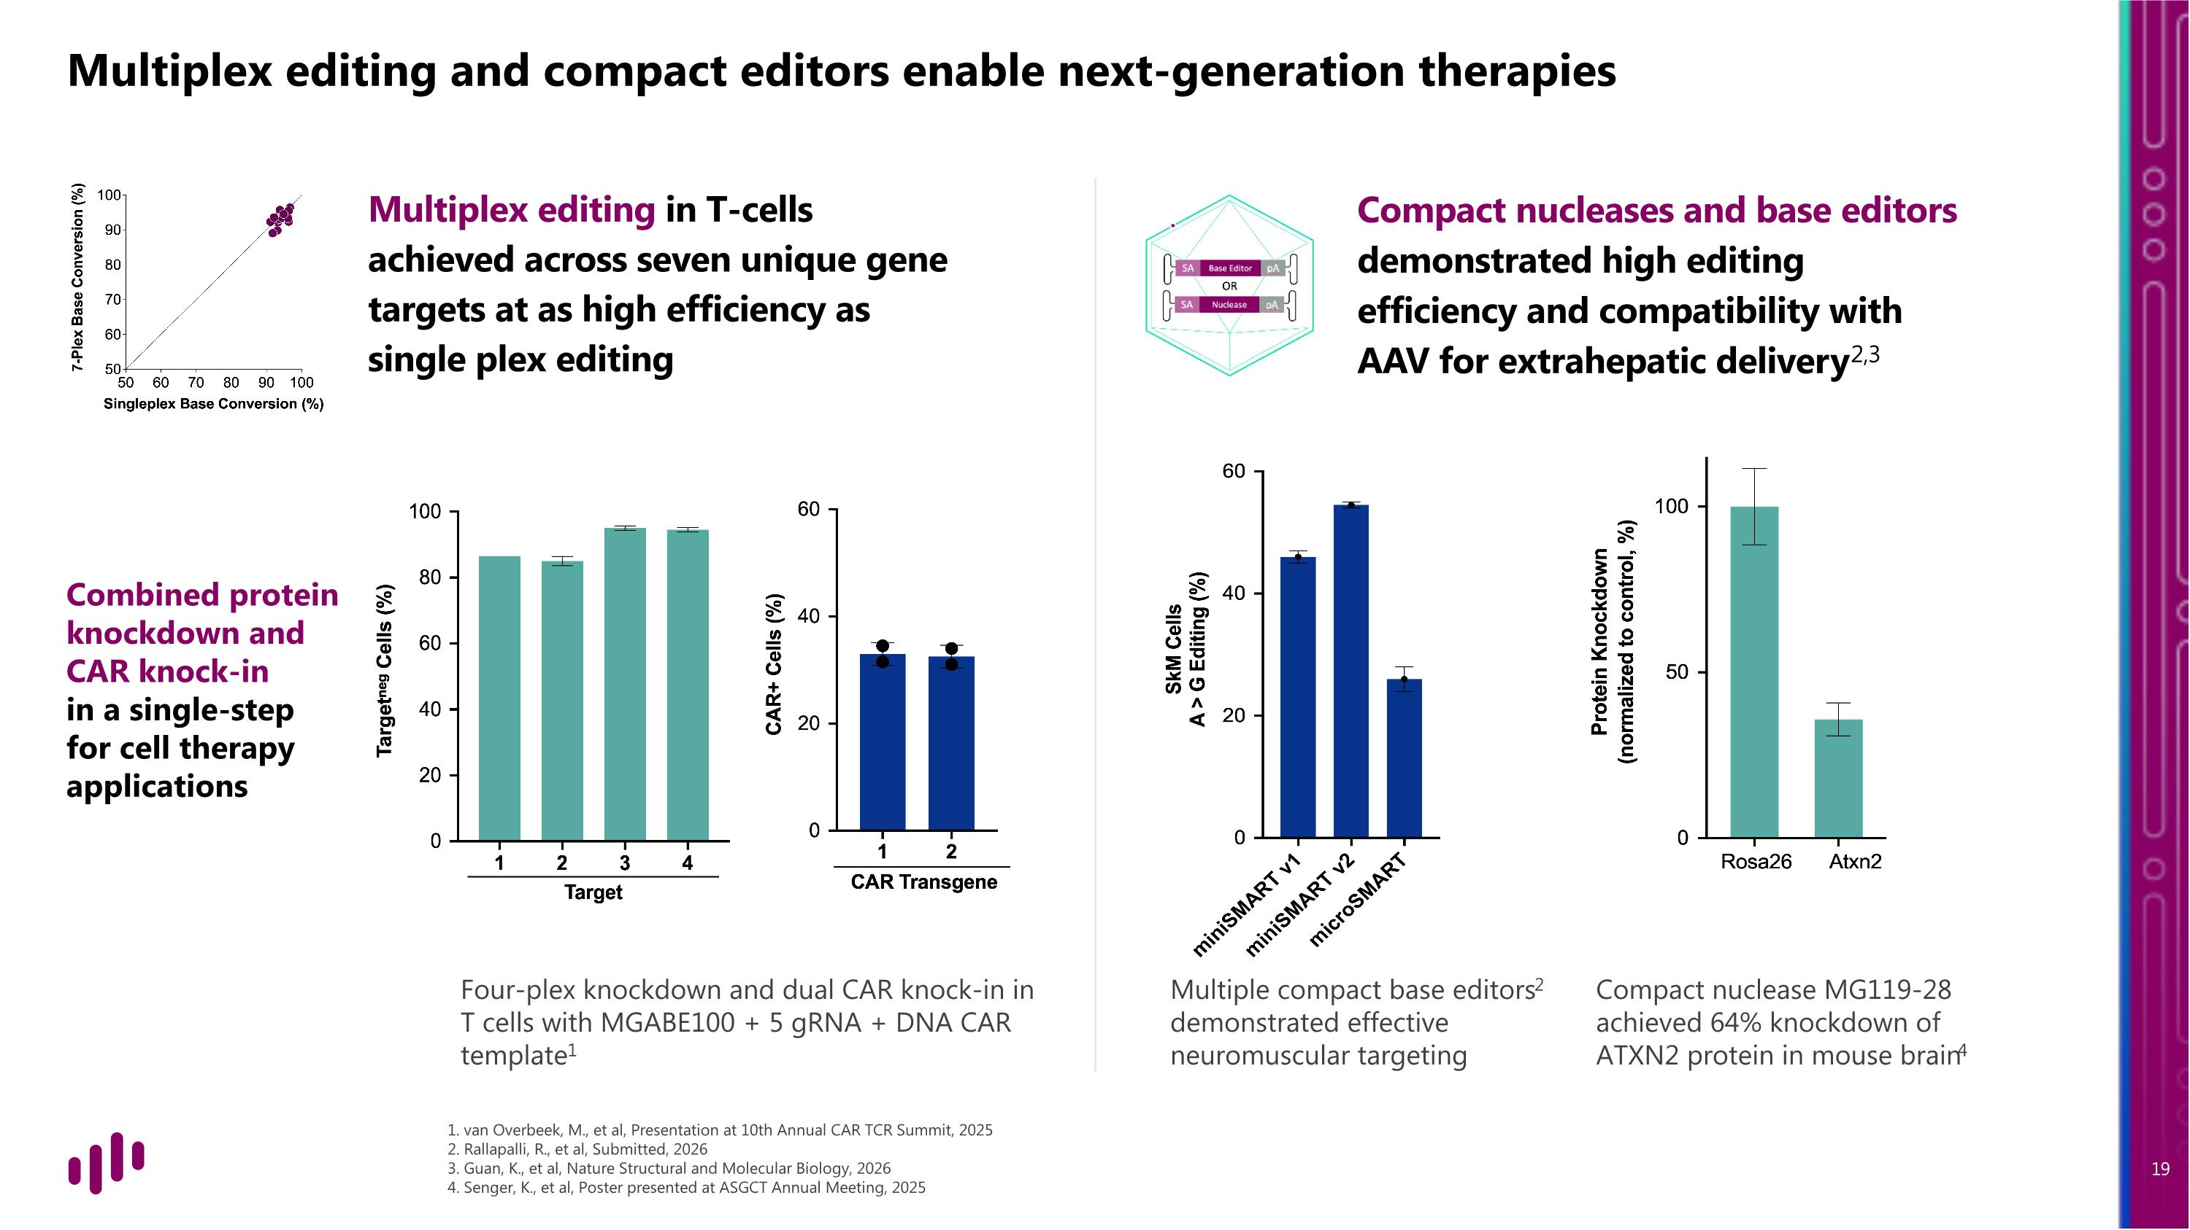
Multiplex editing and compact editors enable next-generation therapies Combined protein knockdown and CAR knock-in in a single-step ?for cell therapy applications Compact nucleases and base editors demonstrated high editing efficiency and compatibility with AAV for extrahepatic delivery2,3 Four-plex knockdown and dual CAR knock-in in T cells with MGABE100 + 5 gRNA + DNA CAR template1 Multiple compact base editors2 demonstrated effective neuromuscular targeting Compact nuclease MG119-28 achieved 64% knockdown of ATXN2 protein in mouse brain4 Multiplex editing in T-cells achieved across seven unique gene targets at as high efficiency as single plex editing 1. van Overbeek, M., et al, Presentation at 10th Annual CAR TCR Summit, 2025 2. Rallapalli, R., et al, Submitted, 2026 3. Guan, K., et al, Nature Structural and Molecular Biology, 2026 4. Senger, K., et al, Poster presented at ASGCT Annual Meeting, 2025

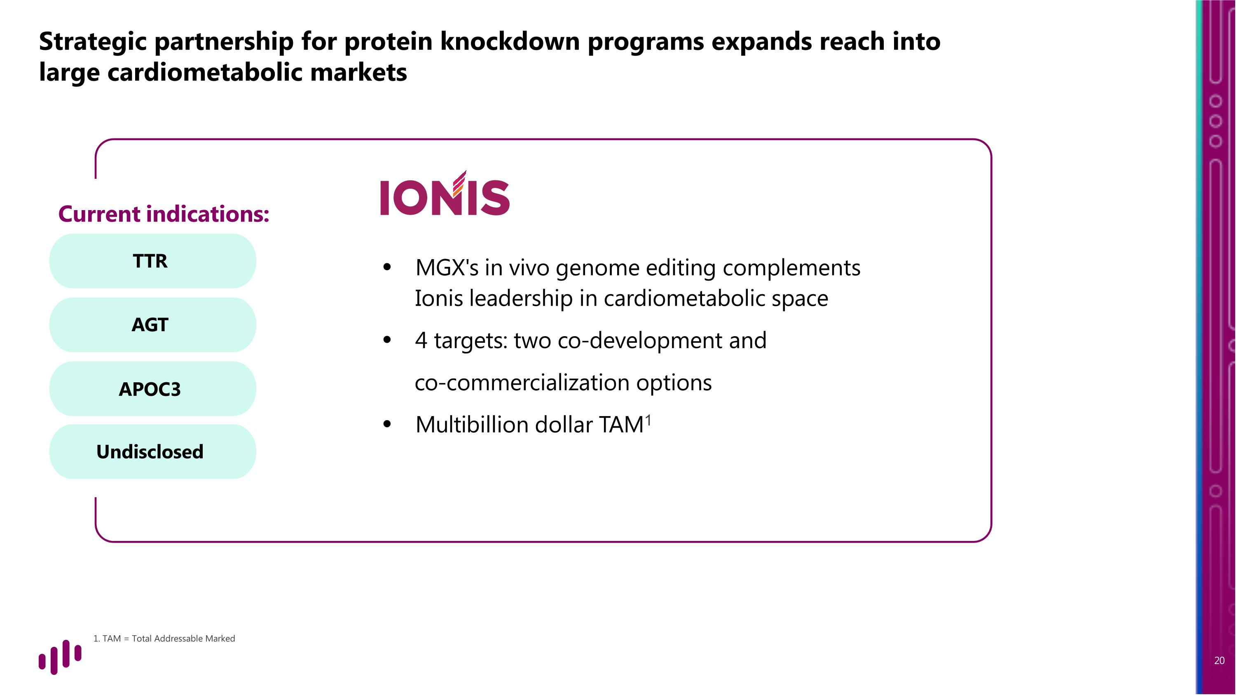
All four targets in Wave 1 are in the lead optimization phase of development and are designed to achieve protein reduction via gene knockout. Strategic partnership for protein knockdown programs expands reach into large cardiometabolic markets TTR AGT APOC3 Undisclosed Current indications: MGX's in vivo genome editing complements Ionis leadership in cardiometabolic space 4 targets: two co-development and co-commercialization options Multibillion dollar TAM1 1. TAM = Total Addressable Marked

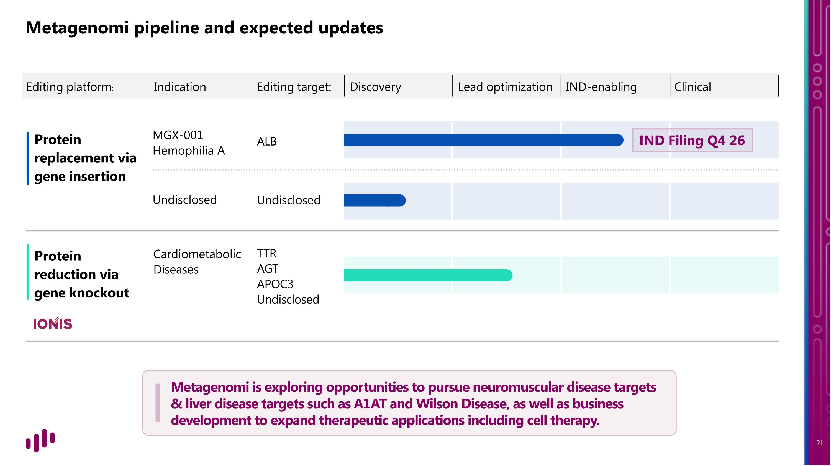
Metagenomi pipeline and expected updates Protein replacement via gene insertion Protein reduction via gene knockout ALB MGX-001 Hemophilia A Undisclosed Undisclosed TTR AGT APOC3 Undisclosed Cardiometabolic Diseases Editing platform: Editing target: Discovery Lead optimization IND-enabling Clinical Indication: Metagenomi is exploring opportunities to pursue neuromuscular disease targets & liver disease targets such as A1AT and Wilson Disease, as well as business development to expand therapeutic applications including cell therapy. IND Filing Q4 26


Thank you

